Choosing and Evaluating Text for Your Reading List

You will be placed at one of the tables in the library and read one of the texts on the table for 5 minutes. Once you have chosen and read for this time, you will record 1) the title of text you chose, (2) its author or editor and if a piece from a larger text (story from short story book or an article from a magazine) the title of the magazine or book), (3) a rating on a scale of 1 to 5 stars (with 1 being least interesting to 5 being ‘very’), and (4) a quick note about why you gave the text the number of stars you did. You will then be instructed to move to a new table of materials and read for another 5 minutes. We will do this until the group has had an opportunity to read and rate at least 10 items. Once we have finished rating the various pieces you have chosen, you will number your selections in the # column from most stars to least. This will form a reading list for you for the next month.

NOTE: If you plan to use materials from home, you are still required to complete this task. It provides feedback for how well you can evaluate and explain, as well as exposure to a number of types of text you will have to read during the semester.

Will this be marked?
You will be evaluated on how thoroughly you have completed the table and how precise your explanation for the item is.

 | 1 | 2 | 3 | 4
Completion of table  B1 Read both independently and collaboratively to comprehend a variety of texts | Completed fewer than 7 entries. | Completed 7 – 9  Entries. | Completed all 10 entries correctly | Completed more than 10 items for the table
Quality of Explanation  B8 Explain and support personal responses. | Vague and flimsy “This book sucks.” | Identified reason for stars but could benefit from more precise language and detail.  “The cover was dull.” | Sufficient reasons provided for rating. “The cover was black and there was no artwork on it.” | Precise and thorough.  “The cover was black and lacked artwork. The first 3 pages had no action and I certainly didn’t like the main character.”

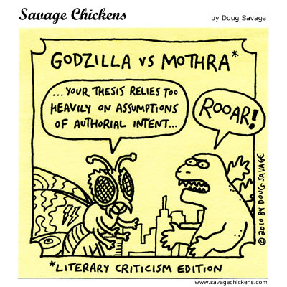

Title | Author/editor/publication* | Star rating | Explanation

