“Inferences: The Educated Guess”

What’s an inference?
An inference is a guess or prediction or assumption we make when we approach a text whether visual or print.

Look at the picture below:

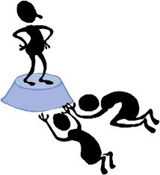

What inferences do you make from it? Why?

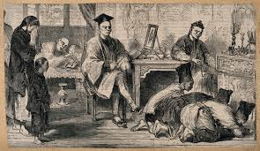
Inferences based on pre-reading/previewing: We often jump to conclusions based on our previous experiences. We can make inferences by :
- Looking at the title and making predictions about the content
- Looking at the style of font
- Looking at the epigraphs or the author.

Inferences based on our biases and experiences.

We interpret a story according to our own personal compass. One person might be afraid of spiders and in reading about a character named Spider immediately makes a less than positive assumption. Another might be fascinated by spiders and make more positive assumptions about the character. We all bring our own cultural and personal experiences to a text and it causes us to make inferences based on these previous beliefs.

Inference based on clues left by the author/artist

Authors choose particular words and phrases which are meant to hint at meaning/theme/ message. All inferences we make in text should be able to be backed up by text/image.

While trying to solve the Kelley Murder Mystery, record your inferences and support each with either personal experience or author clues. Inferences can include conclusions you reached about any of the characters, their relationships, their motives, their roles in the murder and the order of the events/murder.
Inference | Personal experience/bias | Author clues

