Assignment Due Handed
PASSPORT TO SUCCESS

NAME

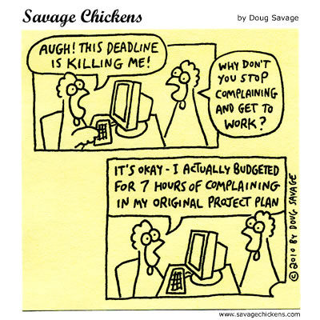
In
Devices visual Sept. _______
WITH RUBRIC

Lyrics assign Sept. _______

Quiz #1 Sept. _______

Narrative essay
Draft Sept. _______
Revised with Sept. 30 _______
rubric attached

Children’s
Book pre-work
Audience LK* Sept. 23 _______
Theme LK* “ _______
Conflict WH** “ _______
Plot WH** “ _______
Sticky note “ _______
Character types “ _______

Review of children’s book

Review Outline Sept. 26 _______
Draft of review Sept. 27 _______
Peer Review Sept. 27 _______
Final Draft Oct. 3 _______
NOTE : Hand all of the review of book
Materials in at the end with your final
draft

* LK = The Lion King
** WH = Willy and Hugh

