WORD OF THE WEEK INSTRUCTIONS

- FIND A VOCABULARY WORD WHICH IS CHALLENGING BUT USEFUL.
EX. Ambidextrous

- Create a mini-poster to show:
- Definition: “The ability to use either hand to do a task.”

- Identify whether the word is a noun, a verb, an adjective, an adverb, or something else.

Noun: a person, place or thing
Verb: an action
Adjective: a word used to describe a noun
Adverb: a word used to describe a verb

Ambidextrous – an adjective.

- Origin: Where does your word come from? This information can be found at the end of a dictionary entry. It might be the root words the word comes from or the situation a word emerged from.
Ex. Ambi – means on both sides
Dexter – means right handed

- Use the word in a sentence showing its meaning clearly.
Ex. The ambidextrous golfer could put using either a left or right handed club.

- A visual example of the word:

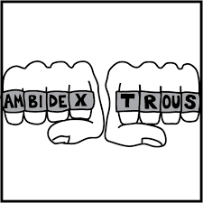

You will show your word to the class and briefly go over your mini-poster

